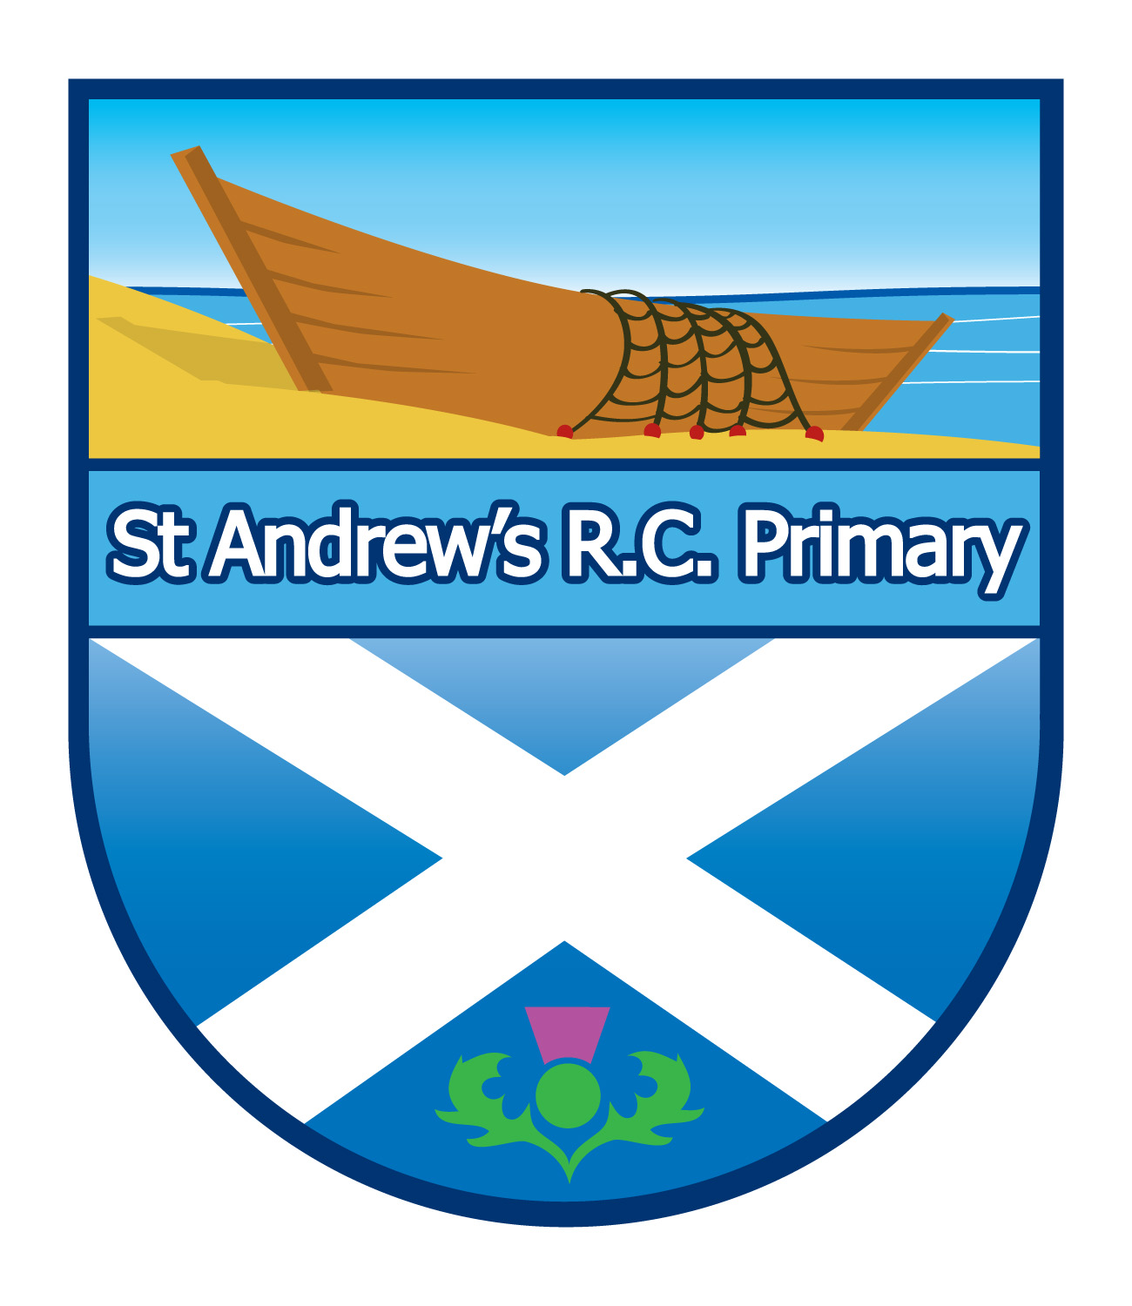
St Andrews R.C. Primary School
45 St. Leonard Place
Dundee
DD3 9HD

Tel: 01382 307830



17th March 2020

Dear Parent/Carer

Coronavirus (Covid-19)

I am writing to update you on Coronavirus (Covid-19) as it relates to you as a family and your children as pupils in our schools.

Dundee City Council’s Children and Families Service is working with head teachers across the city to deal with the impact of the situation as it develops.

The Scottish Government have said there is no need at this stage to close schools. I shall notify you immediately if this advice were to change.

The latest advice from Health Protection Scotland recommends that all educational settings remain open unless we have been advised by the local Health Protection Team to close.

I would ask that you and your family closely follow national health guidance.

If you've developed a new continuous cough and/or a fever/high temperature in the last 7 days, stay at home for 7 days from the start of your symptoms even if you think your symptoms are mild.
If you live with others, then the person who has symptoms of COVID-19 (new continuous cough and/or fever/high temperature) should stay at home for 7 days from the start of their symptoms and all other household members who don’t develop any symptoms should stay at home for 14 days. The 14-day period starts from the day illness began in the first person to become ill.
If others in the household develop symptoms within the 14 days, then they will need to stay at home for 7 days from the day their symptoms began, even if this takes them over the 14 day isolation period.
There is a self-help guide available: https://www.nhsinform.scot or phone 0800 028 2816.

Please see the most up-to-date advice from the NHS: https://111.nhs.uk/covid-19

We are adopting precautionary measures to protect members of our school community and ensure the effective running of our schools.
To help support these measures:
- We are regularly reminding young people of the importance of hand washing and basic hygiene procedures outlined by the NHS.
- Water fountains should only be used to fill water bottles.
- All visitors MUST wash their hands when they come into the school.
Teachers at primary and secondary schools have been talking to pupils about using their Glow account for online learning.

Nurseries will also be advising about learning at home options.

All evening and after school activities and events prior to Easter have been postponed, along with Parents’ Evenings, concerts, shows and sports fixtures.

All school trips have been cancelled in the meantime.

Please be assured that we are taking all reasonable precautions in our schools and are liaising closely with Dundee City Council and NHS staff.

Yours sincerely
Head Teacher

