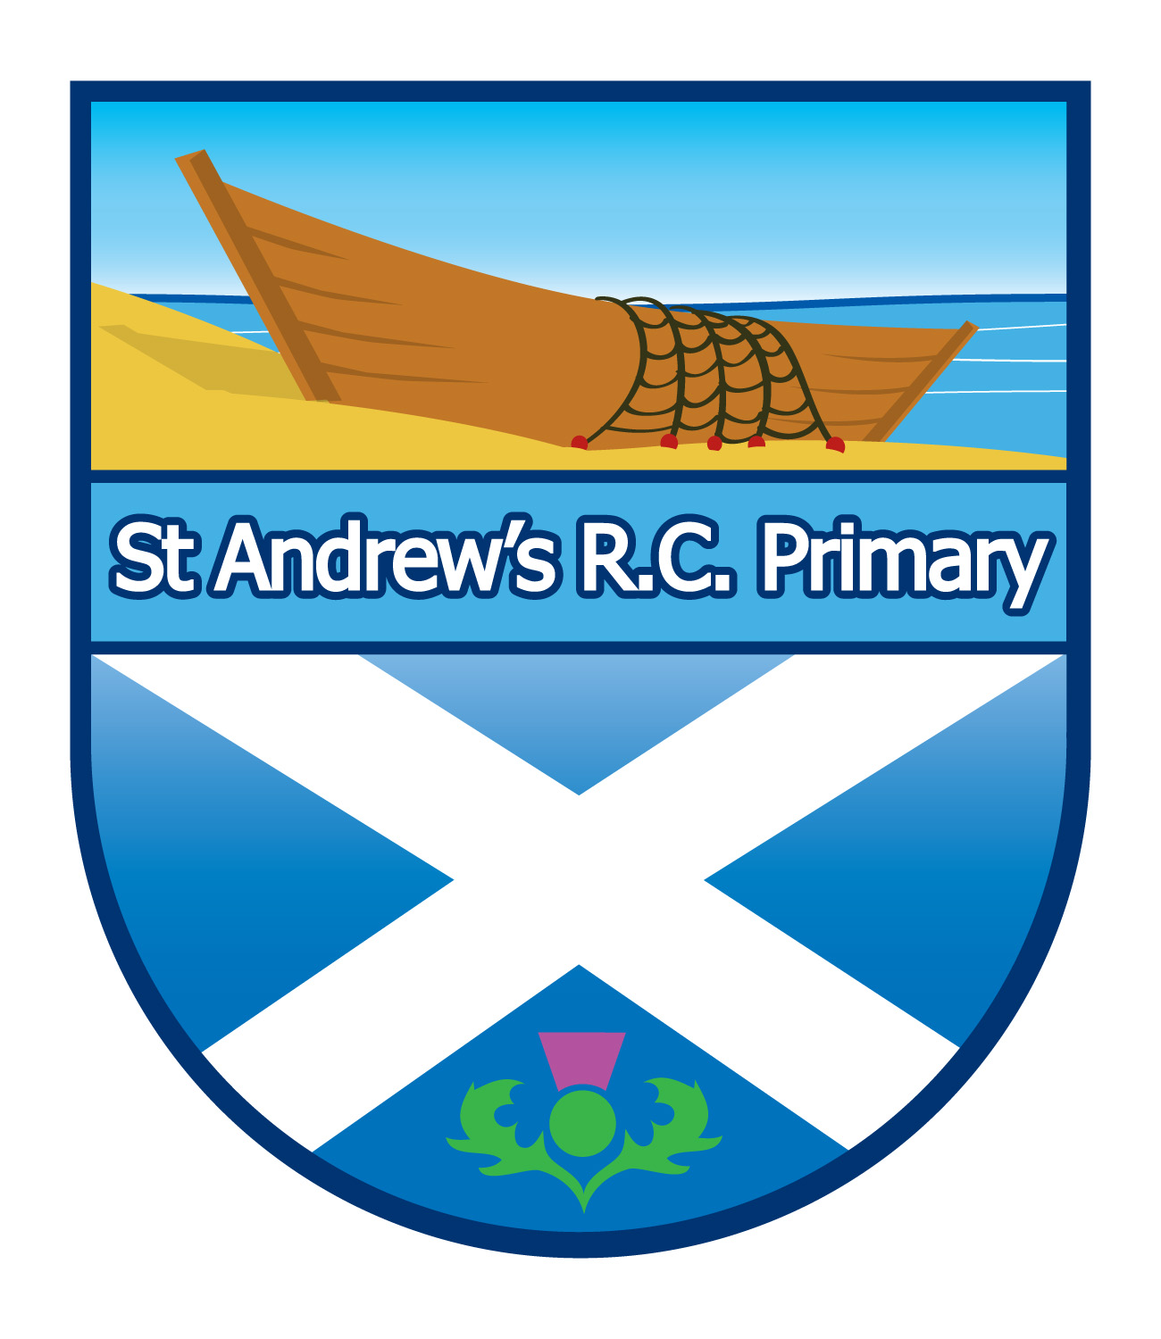
St Andrews R.C. Primary School
St. Leonard Road
Dundee
DD3 9HQ

Tel: 01382 307830
Fax: 01382 819571



12/02/2017

Dear Parents/Carers,
Bring Your Own Device
To further embed digital literacy across learning, our class has been asked to pilot Bring Your Own Device. This means that your child can bring their own tablet or phone to school and use it to enhance their learning. In the first instance, a device can be brought into class on a Monday and a Thursday. The school tablets will be available to use to those who do not wish their child to bring their device to school. The children will have access to school Wi-Fi so data will not need to be used.

Our class have created a code of conduct, which I have attached for your perusal.

Bring Your Own Device will start on Thursday 22nd February.

Yours sincerely

Laura Davidson

